Guide to Using Client Portal For Parents or Guardians

Welcome to Montfort Psychology Associates! As part of our work together, we will be using an online tool called the Client Portal.

To begin using this tool, please follow the steps in this guide or follow the directions on your screen.

- There are two ways to set up your Client Portal account. The first and most common, is by invitation. This process is initiated by our clinic and will include an email being sent to you from “Natalie Montfort”, though the email address will be do-not-reply@theranest.com.

- The body of that email will look like this:

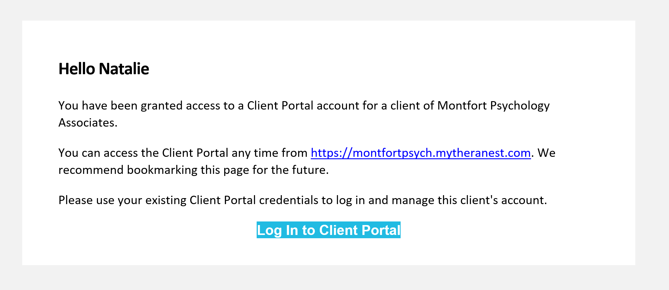

When you are ready to set up your portal account, click the large blue button at the bottom of the email. You may also wish to save the link https://montfortpsych.mytheranest.com to your bookmarks or favorites to help you return as needed.

- Clicking the “Log In to Client Portal” button will take you to a simple webpage that looks like this:

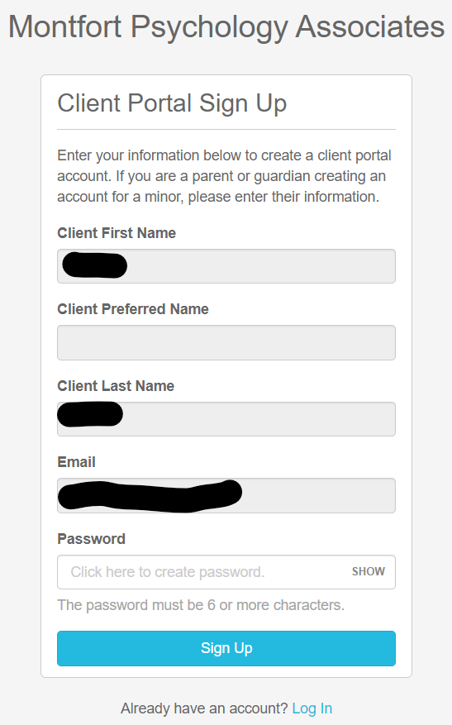

All fields will be pre-filled, except for the Password field. Select a password, and click “Sign Up”.

***Please note that “client” should be the person receiving services, but is often prefilled with the parent or guardian’s name and is not changeable on this screen. Please do not worry- this is a mistake in the programming that the software developers are aware of (it is an old prompt from when parents/guardians did not have a choice to login on behalf of a child/ward).***

- Next, you will be taken to a page where you can enter other information, including Contact Information. You can ensure that you are entering information for your child/ward by clicking on their name and checking which “profile” you are viewing (the client’s or yours).

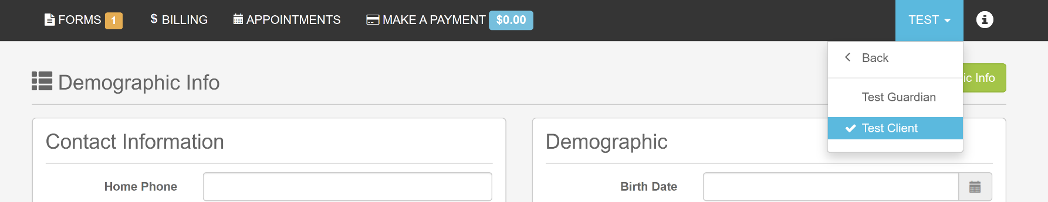

On your child’s profile, the information is related to your child/ward (in the event it differs from your own). There is one exception: Please enter the home and cell phone numbers you would like for us to call to schedule (likely yours, not your child’s/ward’s).

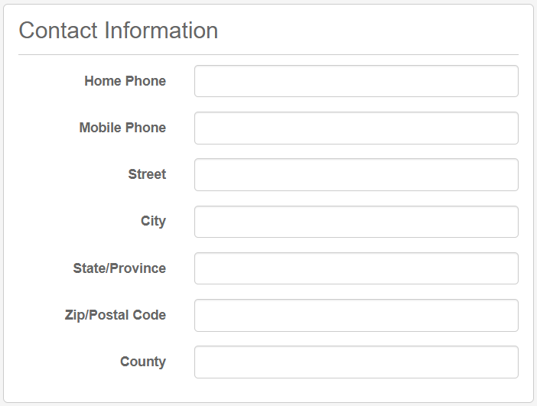

Please enter Emergency Contact information should you and/or your child/ward be unreachable or have a medical problem while in the office:

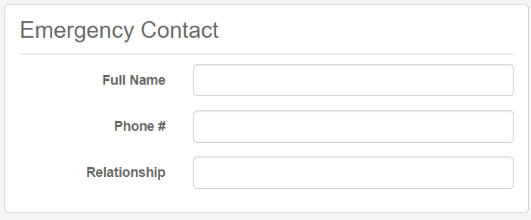
Next, enter Demographic Information. Again, this information pertains to your child/ward and not yourself.

Please complete these sections as thoroughly as possible. Note: Please DO NOT enter a social security number. This information is not necessary for our work together.

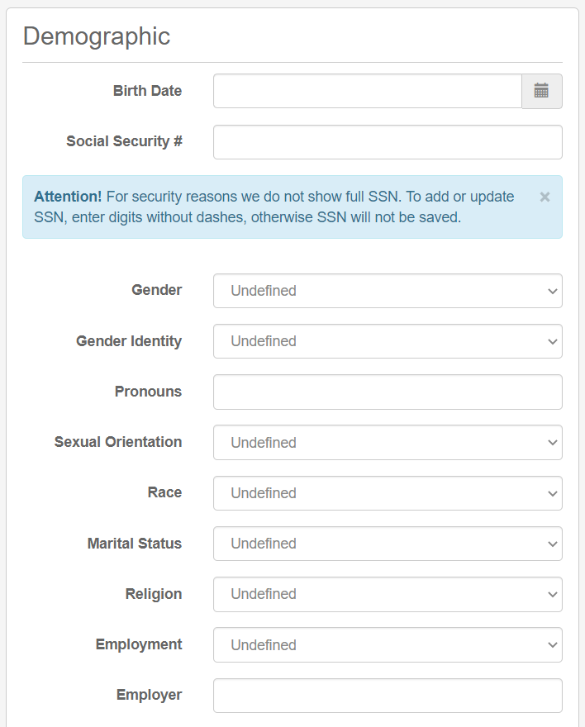

When this information has been entered, scroll to the top of the page and click the “Save Demographic Info” button at the top right.

- After saving your demographic information, Click the “FORMS” button at the top left of the page.

- This will take you to some online intake forms that we have created for your convenience. **Please note: This guide was created with our STANDARD forms. In some cases, depending on the nature of your case and requested services, we may make changes to the number, order, and type of forms we ask you to complete. Please complete all forms presented to you. If you think a form has been included by mistake, please contact nmontfort@montfortpsych.com.**

One of these forms is titled “Notice of Privacy Practices”

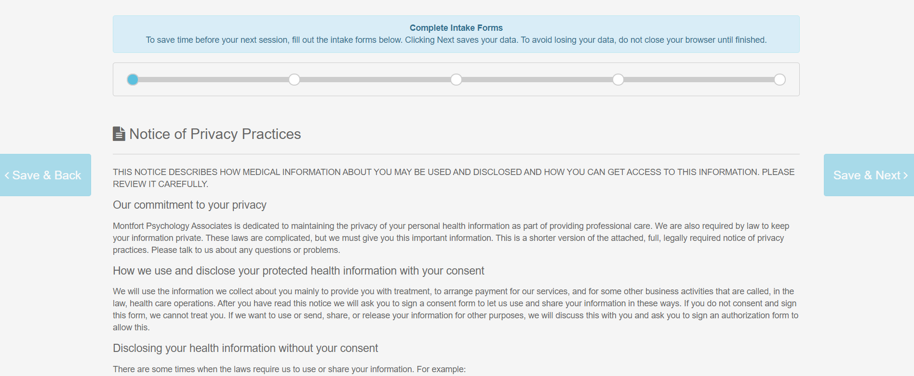

Please read this document carefully and be sure to scroll to the bottom of the page. When you reach the bottom, you’ll see several places for you to enter text. Type your responses into each space and click “Save & Next >” button on the far RIGHT of the page.

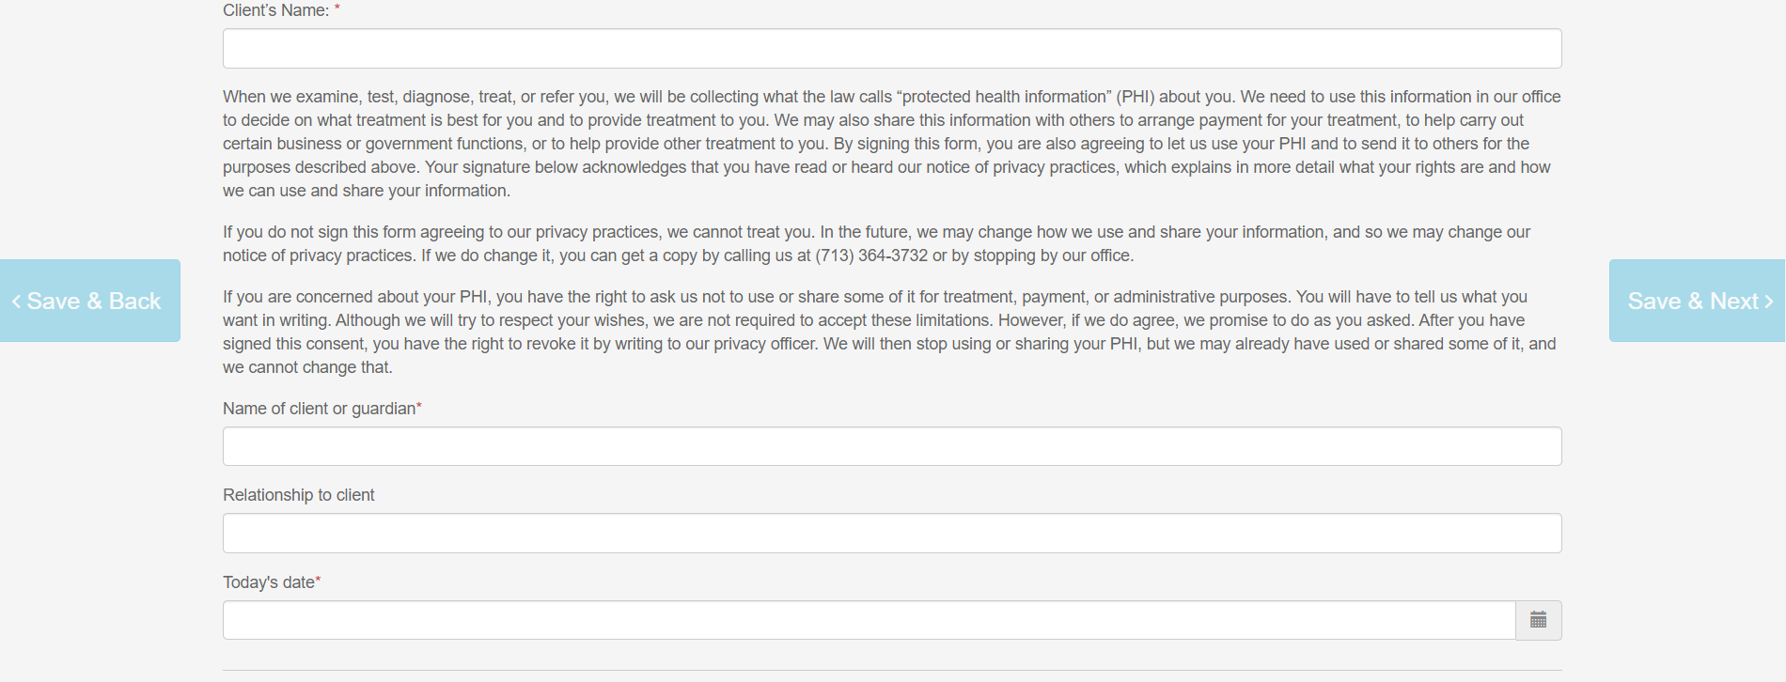

The next document is called “Information for Clients.” This lengthy document describes our company, its services, our policies, etc. Please read this document and enter your signature at the bottom, as before. (Note: due to the length of the document, you may wish to print your own copy – about 15 pages – for future reference.) You will be able to print a copy of all forms at the end of the process.

As before, click “Save & Next” on the right of the page when ready.

Repeat with the Telehealth Consent form

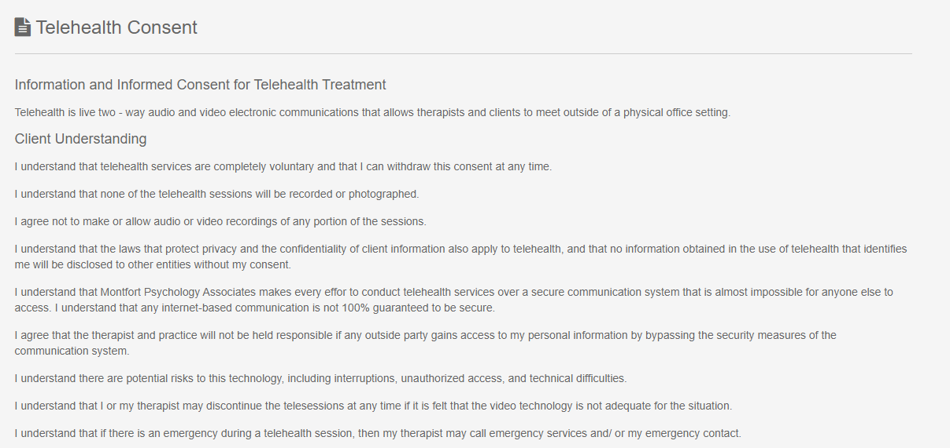

And Credit/Debit Card Payment Consent:

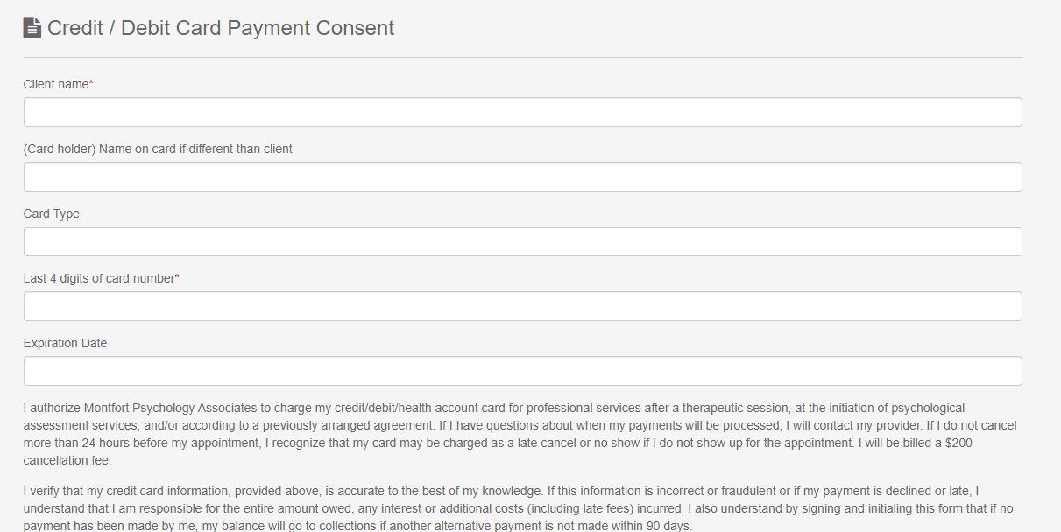

- When all forms have been completed, you will see a review page. (Note the blue progress bar at the top is blue all the way across.)

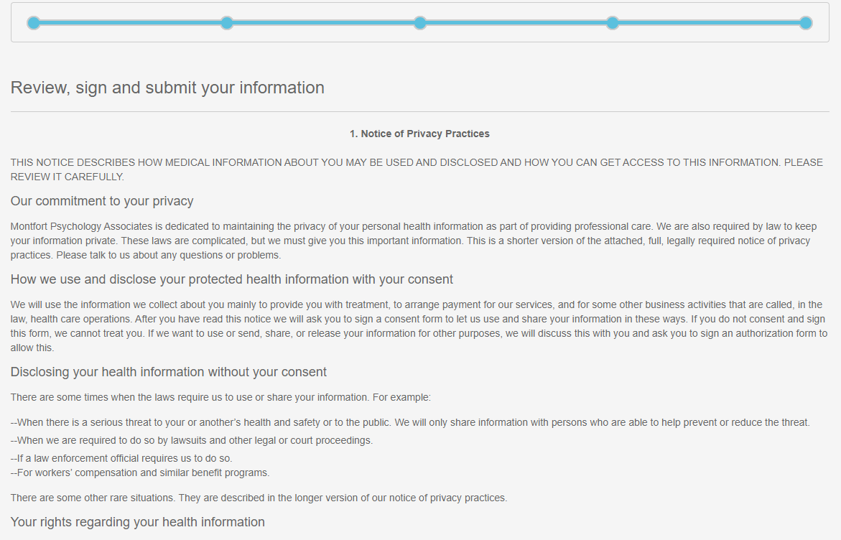

Please review your responses and sign at the bottom of the page and click “Save Signature.” Once your signature is saved (you will see a small thumbnail image to the top right of the large window), click “Sign & Submit” at the bottom of the page.

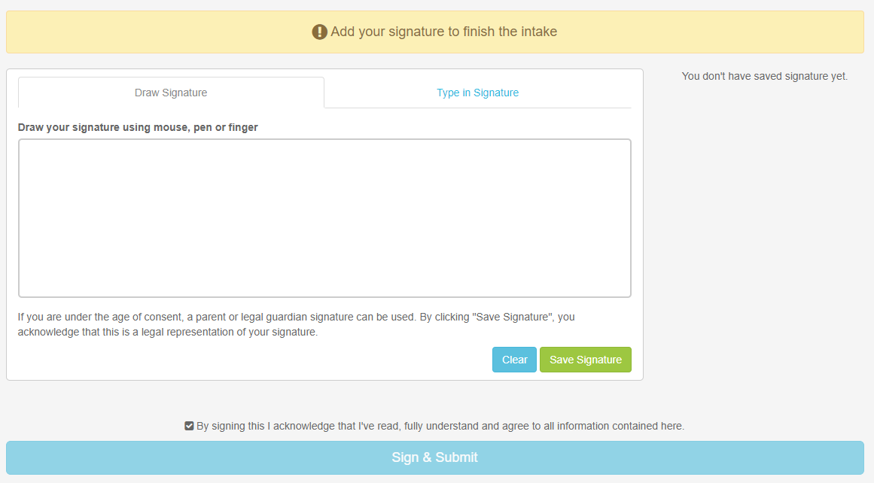
- Congratulations! You have finished the Client Portal process. You will see a confirmation page like this:

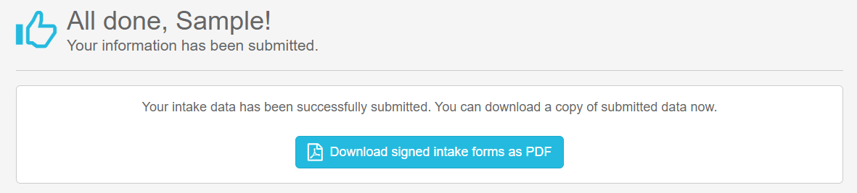

If desired, click the button to print a copy of your signed forms. Dr. Montfort will receive an email informing her that the forms have been completed.

PLEASE ALSO REMEMBER TO RETURN YOUR DEVELOPMENTAL HISTORY FORM! (Attached to your Welcome email.)

If you have completed these Client Portal steps and returned your Developmental History Form, we will be in touch with more information about scheduling!

Thank you! We look forward to working with you!

